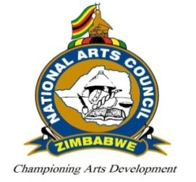

Background to the NAMA legends Awards
The National Arts Council in November 2020 Announced the postponement of the 20th National Arts Merit Awards (NAMA) due to the devastating impact of the Coronavirus Disease (COVID-19) on creativity in the country.
The NACZ Director Mr Nicholas Moyo at a press conference announced that the holding of the competitive NAMA under the circumstances would have jeopardized the credibility of the entire processes associated with the Awards.
Instead, the Director announced that the NACZ would be holding a special celebratory NAMA dubbed “#NAMA legend @40” which would honour 40 legends to put a cap on the country’s 40th Independence anniversary and Celebrate 35 years of the existence of the NACZ.
The event originally penned for 27 February 2021 was postponed to 27 March 2021 after government announced stringent lockdown conditions in the beginning of January 2021. The month-long lockdown affected the services of critical materials and input suppliers who had to work with limited staff numbers and reduced working hours which impacted on their ability to fulfil tasks within the expected time frames hence the decision to postpone.
In addition, the event which initially was going to be a mix between virtual and live event presentation had to take a new dimension as a 100% virtual show following the introduction of stringent controls on gatherings.
With the legends Awards the NACZ intends to honour individuals who have dedicated their lives to the development of their art through their work and assisting others in the sector. The legends are people who are well regarded in their sector who helped define our lives as Zimbabweans with their artworks over a long period.
The awards given to the legends in a sense represent government’s recognition of their talents and achievements which are in line with promoting the national interest, values and aspirations.

#NAMA legends@40: Celebrating Our Legacy, Our Pride.

